Relational Database Design

Descriptions of Each Entity and its attributes

The Customer entity:
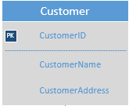

The attributes are:
Attribute | Description
CustomerID | This is the unique identification for each customer. This is the primary key attribute for Customer entity.
CustomerName | This is the name of a customer.
CustomerAddress | This is the address of a customer.

The Item entity:

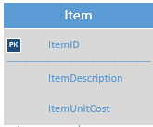

The attributes are:

Attribute | Description
ItemID | This is the unique identification for each item. This is the primary key attribute for Item entity.
ItemDescription | This is the description of an item.
ItemUnitCost | This is the unit cost for an item.

The Order entity:
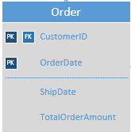

The attributes are:

Attribute | Description
CustomerID | This is the identification number of the customer who has placed the order. This is a foreign key to the primary key of Customer entity. For Order entity, this is a part of primary key and a foreign key.
OrderDate | The date of an order. This is a part of primary key for Order entity.
ShipDate | This is the shipping date for an order.
TotalOrderAmount | This is the total amount of an order. This is the total of the costs of all items in the order.

The entity, Order_Item is an entity for the many to many relationship between Order and Item entities. It includes details of items includes in an order.

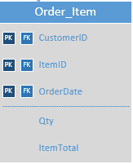

The attributes are:

Attribute | Description
CustomerID | This is the identification number of the customer who has placed the order. This is a foreign key to the primary key of Item entity. For Order_Item entity, this is a part of primary key and a foreign key.
ItemID | This is the identification of the item included in the order. This is a foreign key to the primary key of Item. This is also a part of the primary key of Order_Item.
OrderDate | This is the shipping date for an order and a part of primary key for Order_Item. This is a foreign key that refers to the primary key of Order.
Qty | The quantity of the item for the order.
ItemTotal | The total cost of the item in the order.

Descriptions of the Relationships

- Each CUSTOMER can place one or more ORDERs.
Each ORDER is placed by a CUSTOMER.
- Each ORDER can have one or more ITEMs.
Each ITEM can be a part of zero or more ORDERs.

The Visio ERD
